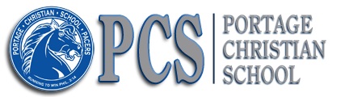
3040 Arlene Street – Portage, IN 46368
P:219.762.8962 – F:219.763.9931

2021-2022 SCHOOL SUPPLY LIST
MS/HS Art Classes
Teacher – Joyce Girgenti jgirgenti@portagechristian.net
- ART BOX (no larger than 8” Tall X 12” Wide)
- Apron or Large Shirt to be kept in art box
- At least two #2 PENCIL, Any Dark/Soft Led Shading Pencil, or Ebony
- Colored Pencils (Prismacolor are higher quality/more costly, but any are fine)
- Nice Eraser
- Clear Ruler (and clear triangle if desired)
- PAINT BRUSHES: at least 1 small/fine detail, 2 sizes flat angled brushes, 1 fan brush, and other preferable sizes
- Water Cup
- Coffee Lid for Paint Pallet

All listed above should fit in art box
- SKETCHBOOK (around 8 ½ X 11)
* Everyone needs their own Sketchbook
- WATERCOLOR PAD (around 9”X 12”)

*The following supplies are available in the Art Room if students do not have their own:
- Watercolor Pencils
- Watercolor Paint Set with Lid
- Black Sharpie: Fine & Ultra Fine Point
- Personal Acrylic Paint and/or Pastels
- Personal Disinfectant Wipes
- Personal Hand Sanitizer

* Siblings may share art supplies, except sketchbook.
* Make sure name is on all supplies and kept in Art Box and Art Room Cubby.
** If any supplies would be a financial burden, please don’t let that prevent your child from coming to enjoy the whole creative experience with us. Let me know privately, via FB Messenger, if your child needs help with art supplies.

